PYTHON PROGRAMMING

CS5590

LAB-1

Done by

Naga Srividya Varanasi (Class ID-22)

Chandra Sekhar Pentakota (class ID-27)

Pujitha Koppanathi (class ID-12)

**Introduction:**

This report is about the python programming using several concepts in python including the usage of different data structures, OOPS concepts.

**Objective:**

The main goal of the project is to get hands on experience on the python programming which includes the use of lists, tuples, data structures, string operations, web scrapping several others.

1. Write a program that computes the net amount of a bank account based a transaction log from console input.

**Approach:**

For any net amount computation, we need to check the transaction log which includes whether the transaction is deposit or withdrawal. If it is deposit then we have add the amount to the total balance else we have to deduct the money from the total balance. Input is taken from the user.

**Workflow:** It consists of source code as well as the output.

**Source Code**

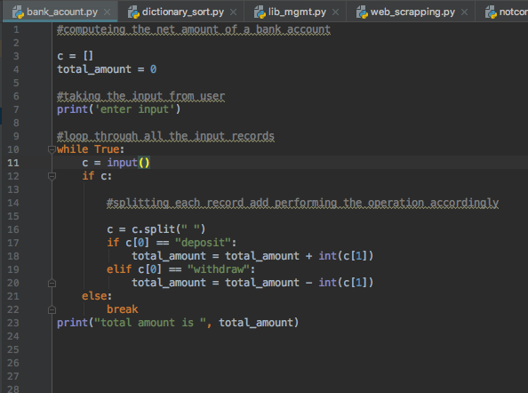

**Output:**

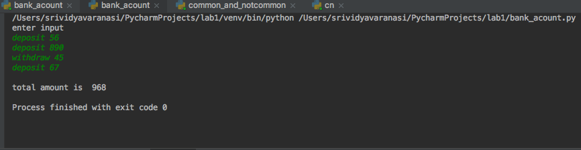

2. Suppose you have a list of tuples, Create a dictionary with keys as names and values as list of (subjects, marks) in sorted order.

**Approach:**

For this program, we have to consider the given list of tuples as input and make a dictionary. We have make use of loop through each and every item in the list based on their indexes to check whether the key is already present in the list or not. If yes, then add the current value to the key else add the new key value to the dictionary.

**Workflow:** It consists of source code as well as output.

**Source code:**

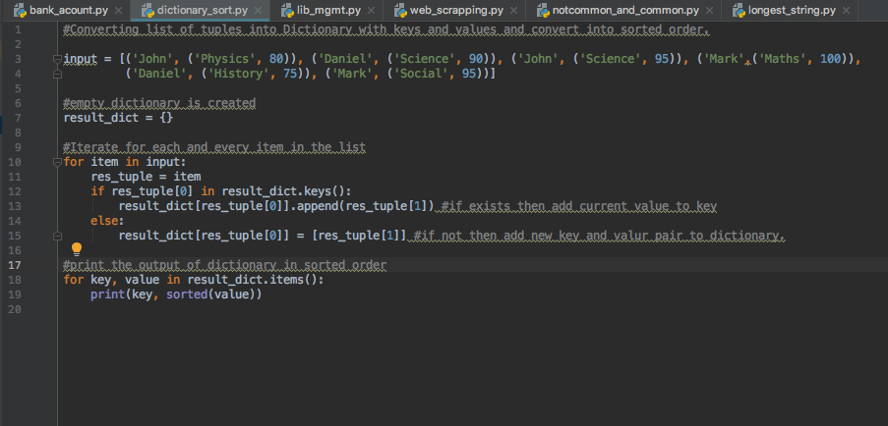

**Output:**

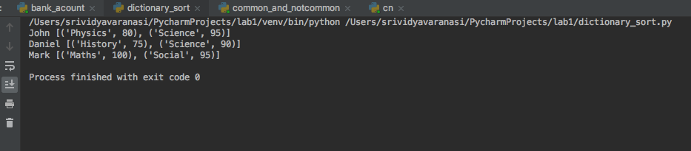

3. Consider the following scenario. You have a list of students who are attending class "Python" and another list of students who are attending class "Web Application".

•Find the list of students who are attending both the classes.

•Also find the list of students who are not common in both the classes.

Print the both lists. Consider accepting the input from the console for list of students that belong to class “Python” and class “Web Application”.

**Approach:**

For this program, initially we created two lists named python and web and then we have used while loop initially to insert the student data into the python class and web class and then we used a for loop to check whether the students in both the class are same or not. Finally we printed the output.

**Workflow:** It consists of source code as well as output.

**Source Code:**

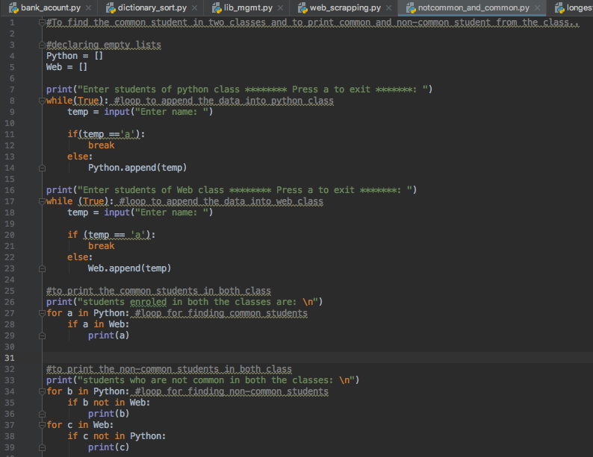

**Output:**

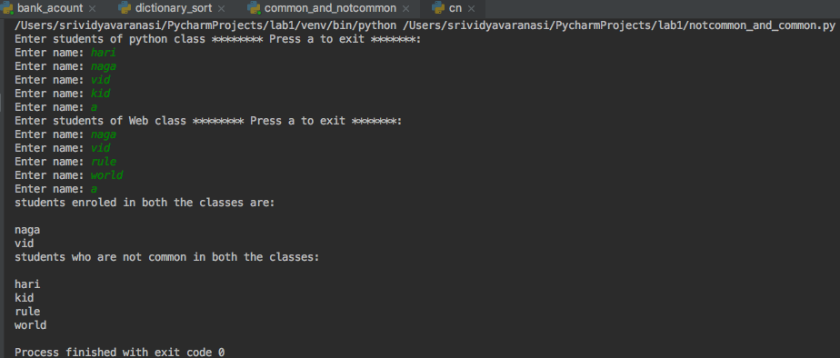

4. Given a string, find the longest substring without repeating characters along with the length.

**Approach:**

For this program we considered an input string. We then initialized two string one to store the current substring and the other for longest substring. We are looping through each and every character whether it already exists or not. We are also comparing whether the current substring length is greater than previous substring or not. Finally we are printing the longest string along with the length of longest string.

**Workflow:** It consists of source code as well as output.

**Source code:**

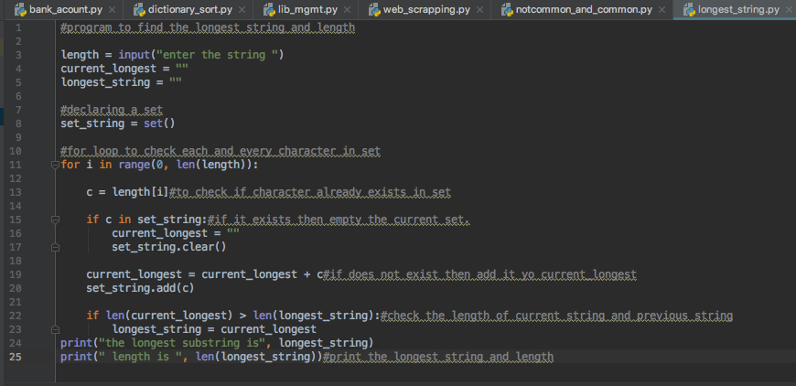

**Output:**

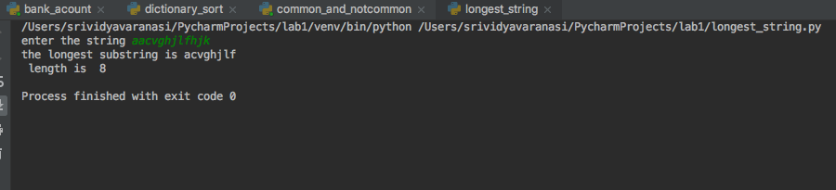

5. Write a python program to create library management systems.

**Approach:**

We wrote the code that has at least 5 classes namely public, student, librarian, book and borrow_book. We used multiple concepts like inheritance, use of self, classes and its instances.

**Workflow:** it consists of source code as well as output.

**Source code:**

Creating a two classes namely pubic and student.

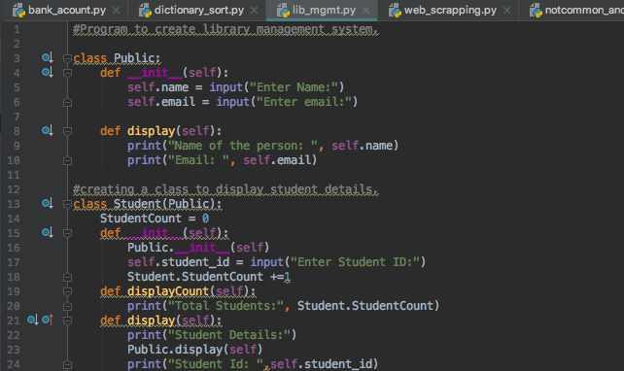

Creating a class for librarian details which includes employee id, employee name and employee Name that is taken from super class public.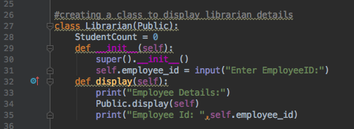

Creating a class for book details namely book name, author and book_id.

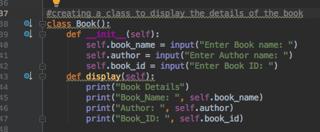

Creating a class for display details of the book that is being borrowed by the student.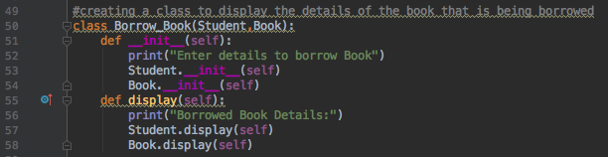

Displaying the details of all the classes

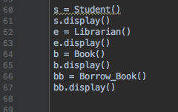

**Output:**

Student details are taken from user and are being displayed.

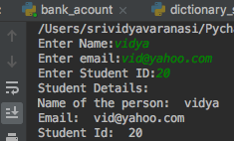

Employee details are being taken by user and displayed

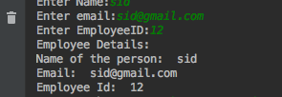

Book details are being taken from user and displayed

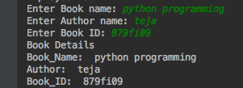

Details of the student who is borrowing the book, along with the book details are shown.

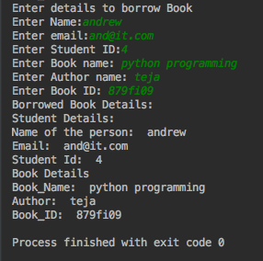

6. Program a code which download a webpage contains a table using Request library, then parse the page using Beautiful soup library. You should save the information about the states and their capitals in a file.

input: https://en.wikipedia.org/wiki/List_of_states_and_territories_of_the_United_States

Sample output: Save the table in this link into a file

**Approach:** Initially downloaded the webpage and parsed the webpage using beautiful soup library. We then opened a text file to store the state and capital of different states in United States.

**Workflow:** it consists of source code as well as output.

**Source code:**

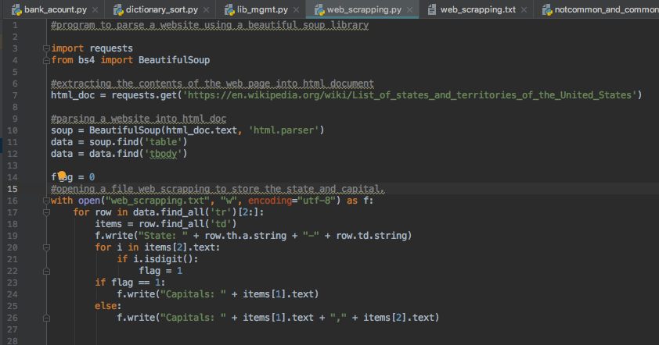

**Output:**

